**Assignment 12-Spark Examples**

**Example 1: Using parallelize()**

* Importing PySpark
* Then Importing Spark Session
* Creating a RDD using parallelize()
* Printing RDD

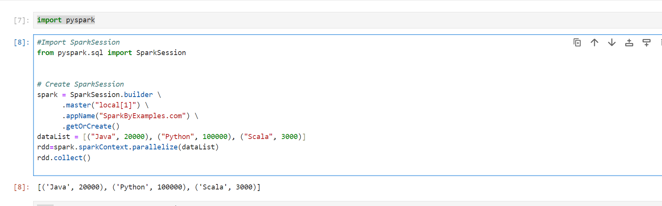

**Example 2: Using .textfile()**

* Importing PySpark
* Then Importing Spark Session
* Creating a RDD using .textfile()
* Printing RDD

